How to organize a successful conference

Giuliana Rossi¹, Alessandro Rebez¹, il Comitato Tecnico Scientifico del GNGTS ^{2,3,4,5,6} , il comitato locale ⁷

¹ Istituto Nazionale di Oceanografia e di Geofisica Sperimentale –OGS Centro di Ricerche Sismologiche, Italy

² Dipartimento della Protezione Civile Nazionale

³ Istituto Nazionale di Geofisica e Vulcanologia INGV

⁴ Consiglio Nazionale delle Ricerche CNR

⁵ Sezione Italiana EAGE-SEG

⁶ Consorzio ReLUIS (di seguito “ReLUIS”)

⁷ università di Udine

We hope to organize also this year a nice conference for you: we chose to have it in Udine, because in 2026 the Friuli region remembers fifty years from the devasting earthquakes of 1976. Hence, it was a good opportunity to invite all of you to visit this nice town and its wonderful surroundings…while discussing of science!
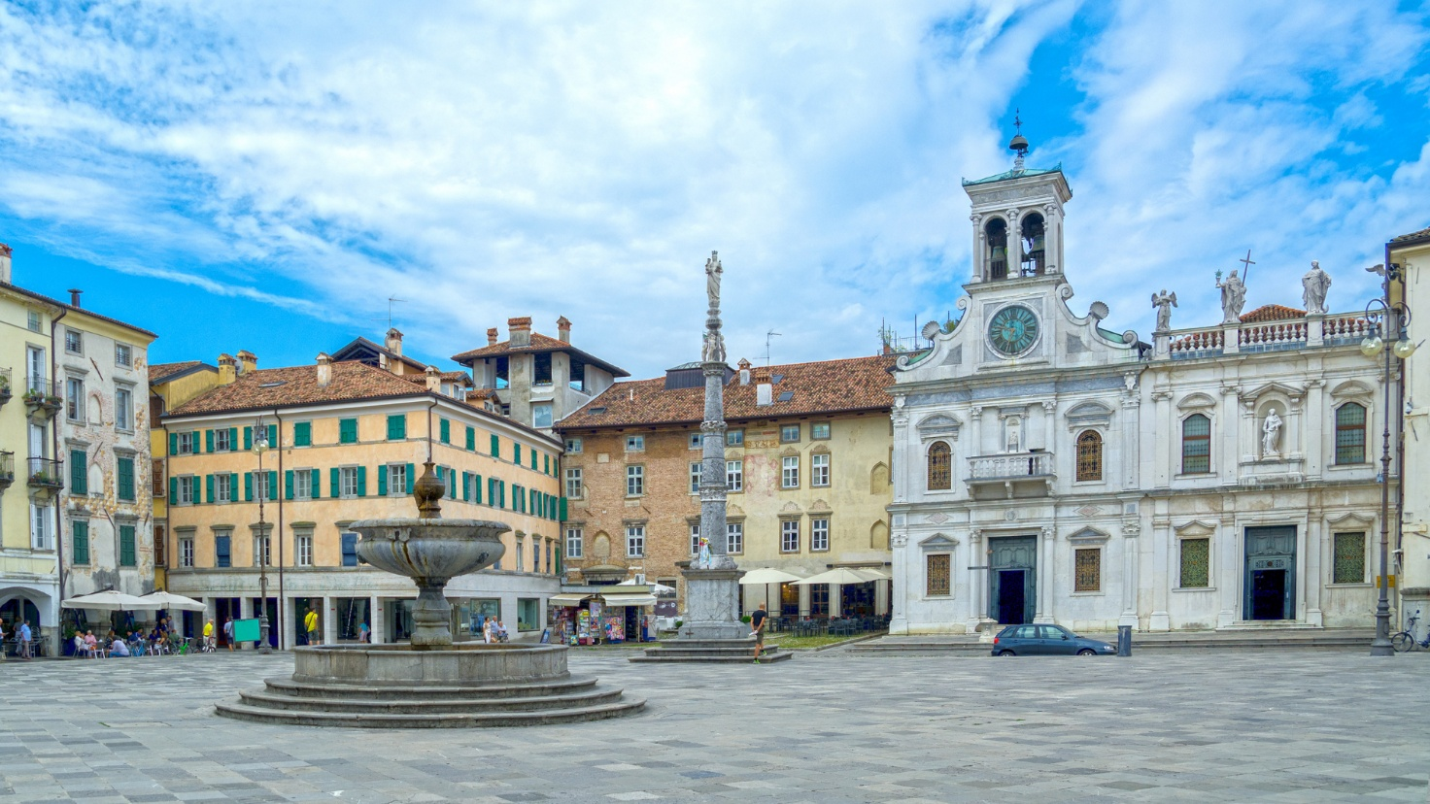

Fig. 1 – The central place Giacomo Matteotti in Udine
The conference is organized in collaboration with the University of Udine and will be held at the technological campus of the Udine University “I Rizzi”, that will host us with a nice Auditorium, and the building Feruglio, with its various rooms and a wide space in between.
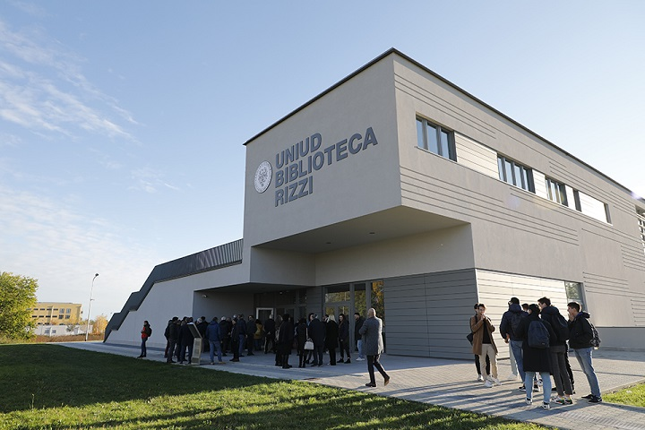

Fig. 2 – The Auditorium of the Biblioteca that will host the plenary of February 12, 2026.
The sessions will be organized in the three known themes, that you find on the web site.
In addition, this year we organize a field trip in some of the most significant places of the 1976 earthquake, and in a geological site.
Acknowledgments
We thank all of you for your presence in our conference
References
Slejko, D.; 2020: The Italian Group for Solid Earth Geophysics. Bollettino di Geofisica Teorica ed Applicata Vol. 61, n. 1, pp. 103-118, https://doi.org/10.4430/bgta0295
Corresponding author: grossi@ogs.it

