How to organize a successful conference

Giuliana Rossi¹, Alessandro Rebez¹, il Comitato Tecnico Scientifico del GNGTS ^{2,3,4,5,6} , il comitato locale ^{7,8}

¹ Istituto Nazionale di Oceanografia e di Geofisica Sperimentale –OGS Centro di Ricerche Sismologiche, Italy

² Dipartimento della Protezione Civile Nazionale

³ Istituto Nazionale di Geofisica e Vulcanologia INGV

⁴ Consiglio Nazionale delle Ricerche CNR

⁵ Sezione Italiana EAGE-SEG

⁶ Consorzio ReLUIS (di seguito “ReLUIS”)

⁷ Università di Roma La Sapienza

⁸ Università di Roma TRE

Corresponding author: grossi@ogs.it
We hope to organize also this year a nice conference for you: we chose to have it in Rome, at the CNR principal premises, for the occasion of the merging of IGAG, IGG, IRPI in the new Istituto di Geoscienze (GEO). For GNGTS is a “returning home” in the site where the first conferences were held, in the capital, where various earth science Research institutes and University departments are operating.
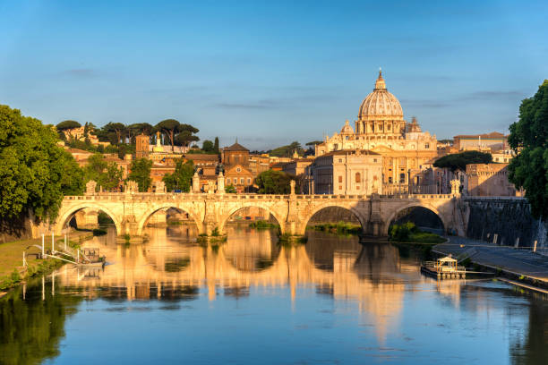

Fig. 1 – Un’immagine di Roma, con il Tevere e San Pietro
The conference is organized in collaboration with CNR and will be held at the principal premises of CNR in Piazzale Aldo Moro 1.
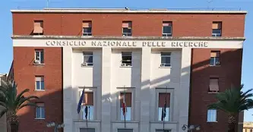

Fig. 2 – The CNR main building in Piazzale Aldo Moro 1, where the conference will be held.
The sessions will be organized in the three known themes, that you find on the web site.
Following the success of last year, this year we organize a geological field trip of the ancient Rome, the afternoon of Monday February 22nd.
Acknowledgments
We thank all of you for your presence in our conference
References
Slejko, D.; 2020: The Italian Group for Solid Earth Geophysics. Bollettino di Geofisica Teorica ed Applicata Vol. 61, n. 1, pp. 103-118, https://doi.org/10.4430/bgta0295

